FOR TWP COMMUNITY LIBRARY SPACE:

How to check out books

Step 1: Get Your “Library Card”: https://forms.gle/VdoARigYcNXiUeAbA
We check our email once a day so please be patient with us. You are welcome to take the book home and scan it out when you get your account notification. 😀

Step #2:
- Visit Village Books or go to the library homepage:
https://www.libib.com/u/twpcommunitylibrary
- Check out our awesome (ever-growing) collection of books
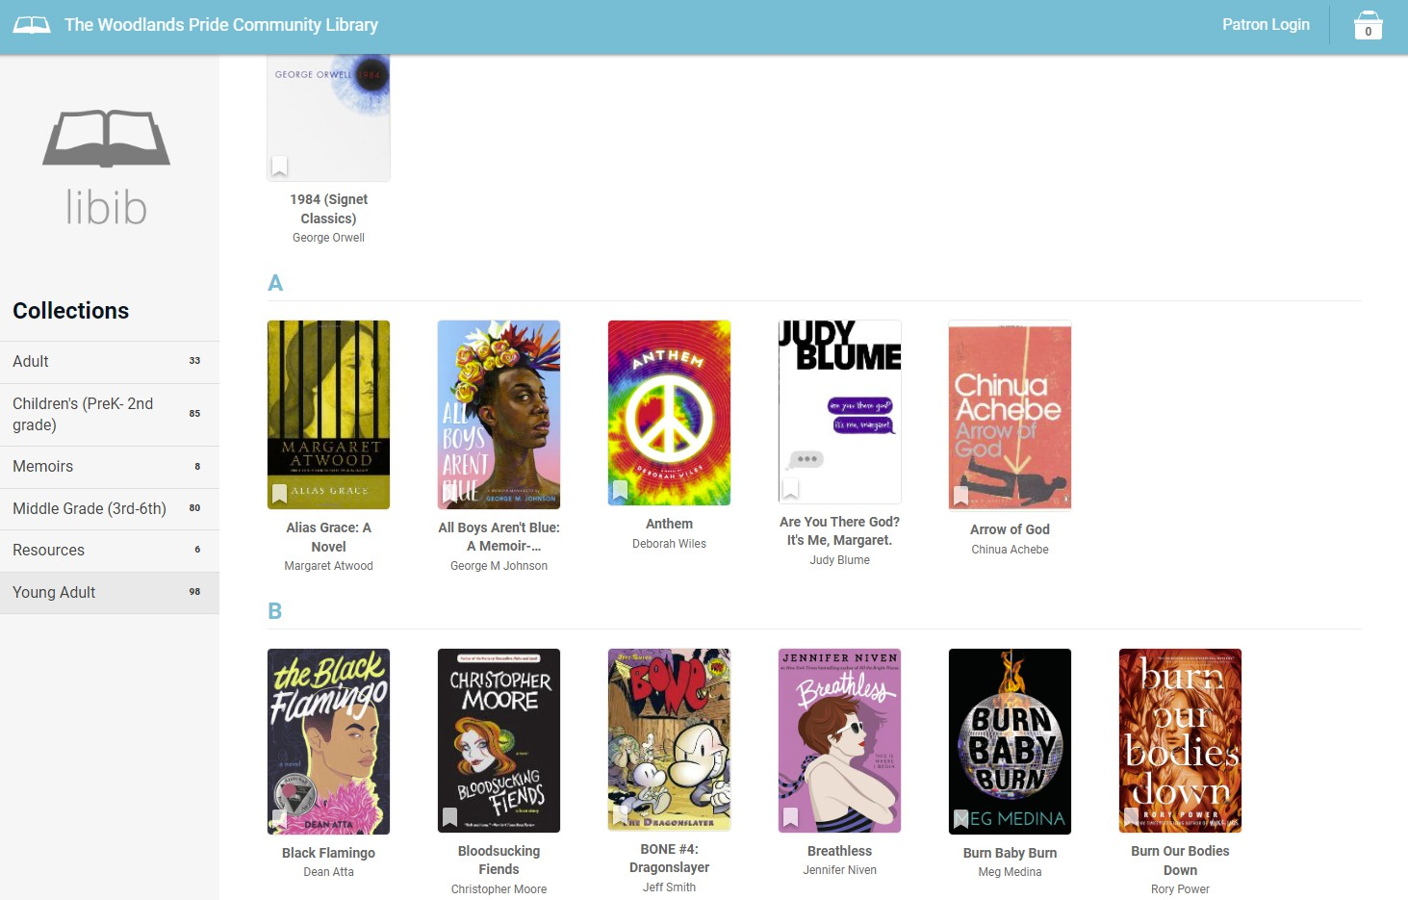
- Select the book you are interested in.
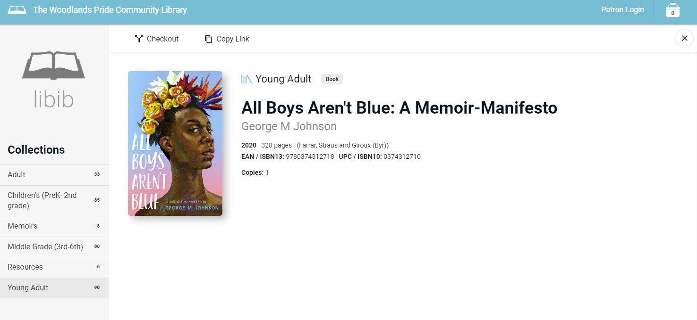
- Select the “Checkout” Option at the top of the page, which will add it to your cart.

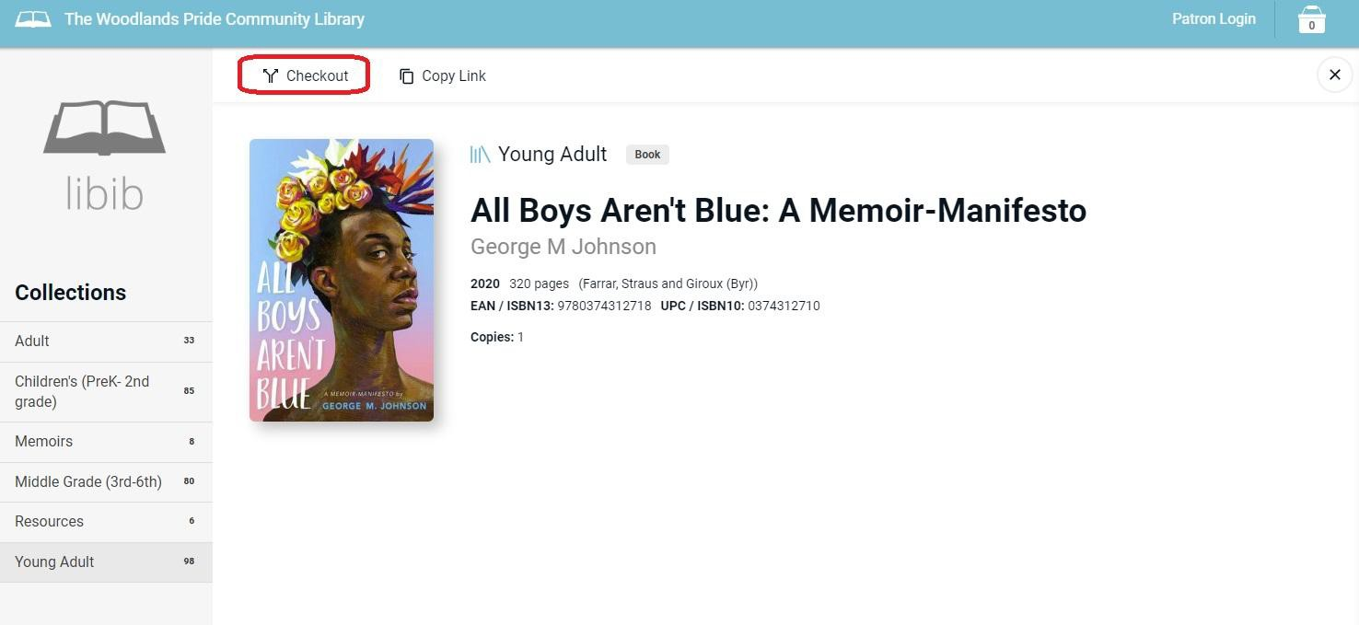
- You can either:
  - Continue browsing for more books
  - Click on the button that says “Complete”.
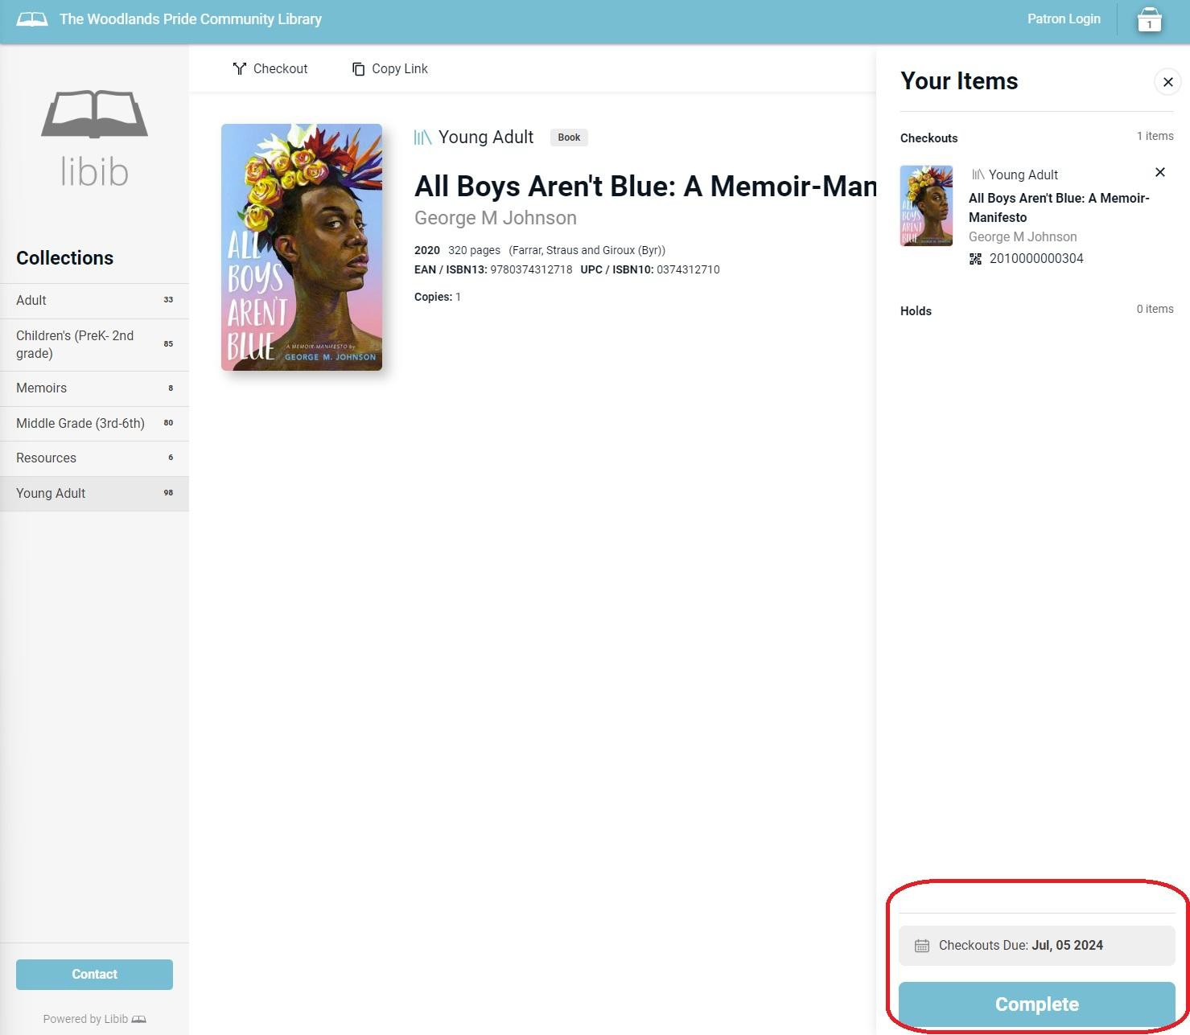
- When you are ready to checkout, click on the button that says “Complete”. The following window will appear:
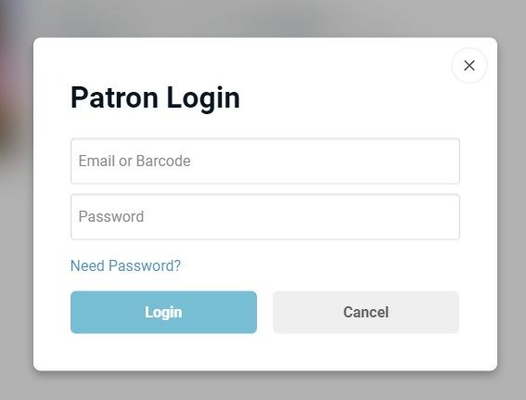
If this is your first time checking out with us, fill out the following form to get your “Library Card”: https://forms.gle/VdoARigYcNXiUeAbA
  - This will allow us to register your email address.
- After you have your “library card”, it’s book time!

